Oceania-Borneo-Dayak-Mask-Wood-pre 1950

# 

# Order details

## Sales order

Sold by [new-guinea-art](http://myworld.ebay.com/new-guinea-art) ( [9392](http://feedback.ebay.com/ws/eBayISAPI.dll?ViewFeedback&userid=new-guinea-art) )

### Delivery package 1 of 1

Estimated delivery Thursday, Mar 24, 2016 - Friday, Apr 1, 2016

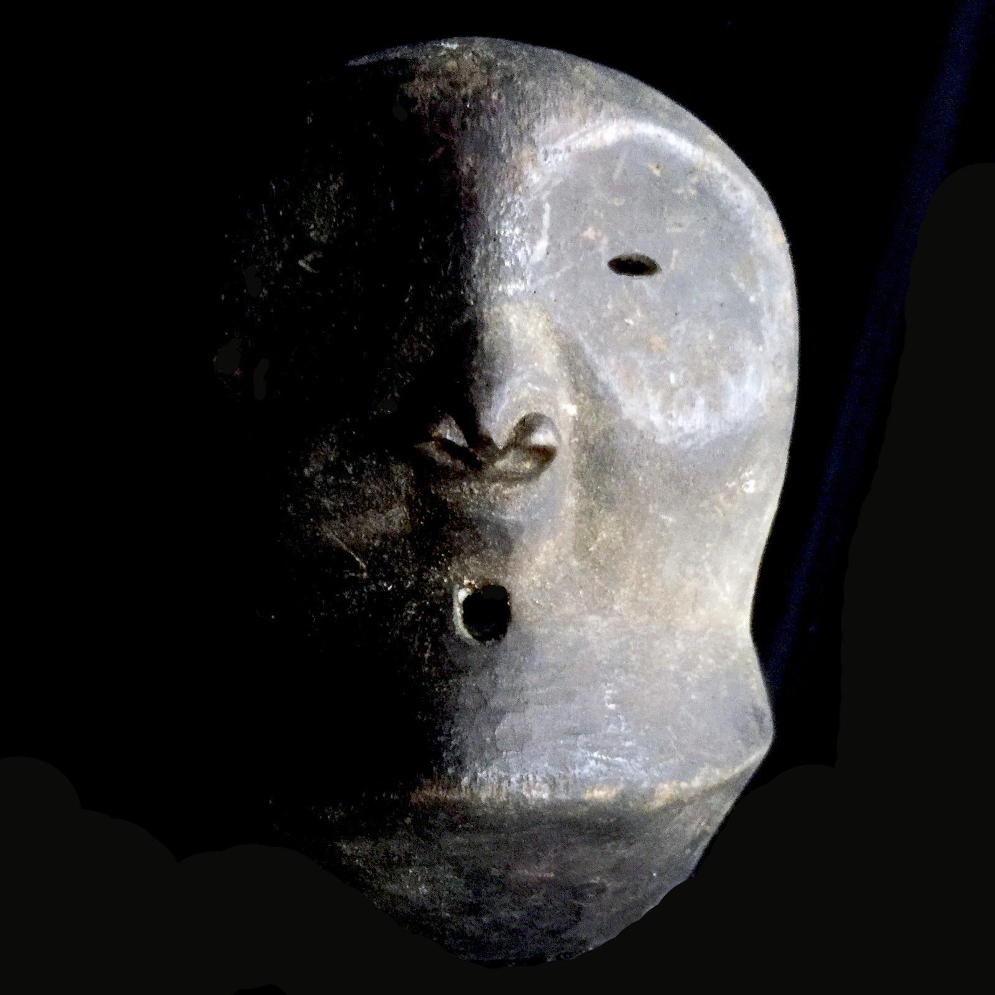

#### [ABSOLUTELY TOP MASK Inland BORNEO Dayak people Indonesia pre-1950's](http://www.ebay.com/itm/191823439053)

|  |  |
| --- | --- |
| Item price | $60.00 |
| Quantity | 1 |
| Item number | 191823439053 |
| Shipping service | Standard Shipping |

## Shipping address

Ralph J Coffman Jr

149 Atlantic Ave

Swampscott MA 01907-2427

United States

## Order total

|  |  |
| --- | --- |
| Subtotal | $60.00 |
| Shipping | $30.00 |

**Total**

$90.00

Order placed on

Thursday, Mar 17, 2016

Payment method

PayPal

Payment date

Thursday, Mar 17, 2016